

*“The purpose of computing is insight, not numbers”*

***Richard W. Hamming - The art of doing science & engineering -* 1986**

**Introduction**

Theatre is about to begin. We will explore the interactions of *electric & magnetic fields* under different conditions. Electrostatics and magnetostatic phenomena are notorious for being among the most difficult to deal with in the lab. In the following pages, we will show how we have addressed these challenges both experimentally and computationally.

As *John P. A. loanidis* showed in *(2005) "Why most published research findings are false"*, we live in an era where most published scientific studies are difficult or even impossible to reproduce. Since *reproducibility* of experimental results is an essential part of the scientific method, the inability to replicate the studies of others has serious consequences for many fields of knowledge, not to mention how it slows down technological development in industry and adoption in society. Although this ongoing crisis primarily affects the field of medicine and social science, we want to contribute to a healthier research environment.

data, methodologies, source code and results are public and free to be examined at the following [link](https://github.com/Fylls/electromagnetism-experiment).

**Table of contents**

**Experiment 1**  3

Theore tical Backgound 3

Experimental Apparatus 4

Procedure 5

Physical Models 6

Results 8

Statistical analysis 10

**Experiment 2**

Theore tical Backgound 13

Experimental Apparatus 13

Procedure 14

Results 15

Statistical analysis 18

**Acknowledgements**  22

**Experiment 1**

assumptions and models for the calculation of the capacitance of a flat parallel plate capacitor

**Abstract**

In the experiment, we have two circular flat plates of radius R at a fixed initial distance of 1mm charged with a DC power supply. The capacitor can vary its capacitance since one of the plates is fixed, while the other is free to slide along a rail fitted with a metric scale. The aim of this first experiment is to measure the capacitance $C$ and the potential difference $∆V$ under different assumptions and models.

**Theoretical Background**

**Capacitance**

If a potential difference is applied to the plates of a capacitor, the charges separate, and an electric field is generated within the *dielectric* (in this case air). The armature connected to the highest potential is positively charged, while the other is negatively charged. The positive and negative charges on the two plates are equal in absolute value. The ratio between the charge $Q$ and the applied potential $∆V$ is called capacitance $C$ and it is measured in *farad* ($F$).

$$globally: Q = ε_{0} \oint{ε_{r} E∙dA} ∆V= \int_{-}^{+}{E∙dS} C= \frac{Q}{∆V}=\frac{ε_{0} \oint{ε_{r} E∙dA}}{\int_{-}^{+}{E∙dS}}$$

**Hypothesis 1: Capacitor operates in vacuum**

The dielectric characteristics of air for electric fields well below $3,94 ∙{10}^{4} V/m$ are very similar to those of vacuum. Having calculated the maximum electric field reached inside our capacitor, we find that $2 ∙{10}^{3} V/m$ amply verifies this assumption. For subsequent calculations, we will neglect the relative dielectric constant.

$$ε_{r}=1$$

**Hypothesis 2: Capacitor is flat**

The capacitance of a capacitor with flat parallel plates depends entirely on its geometric parameters. The local geometry of a flat capacitor allows important simplifications to be made for all points away from its edge. It is consequently assumed that E is constant throughout the volume between the plates.

The following formulas would apply globally if we were studying an infinite parallel plate capacitor.

$$locally: Q = ε_{0} E A ∆V= E d C= \frac{Q}{∆V}=\frac{ε_{0} A}{d}$$

**Experimental Apparatus**

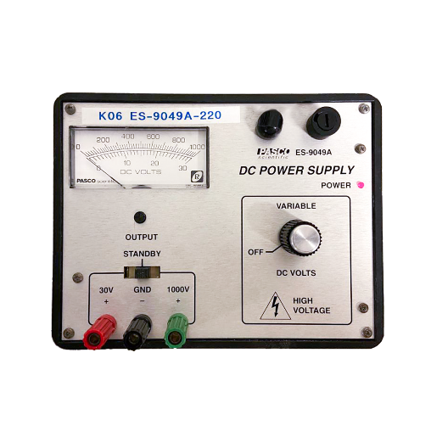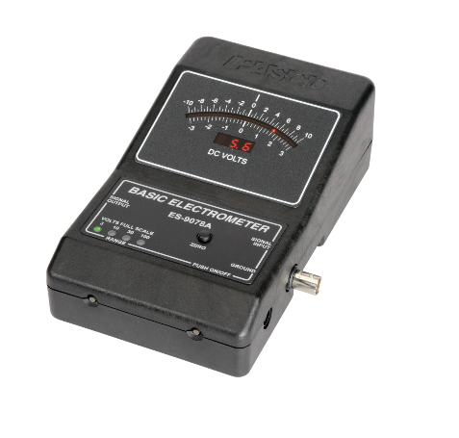

**Capacitor**: formed by two armatures (disks) of radius 10cm. One of the two disks is free to slide along a rail fitted with a metric scale with 1mm sensitivity.

**DC Power Supply:** used to charge the plates up. Adjustable voltage.

**Voltmeter:** used to measure the potential difference between the two armatures. Can be set to three different scale funds to make measurements at different voltages. Analog device.

**Anti Static Wrist Strap Band:** important for security reasons

Below, we report how the equipment is connected

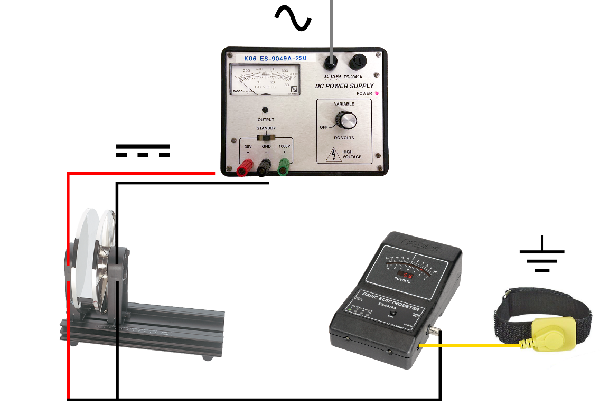

**Procedure**

To begin, we removed all the objects not related to our experiment to not disperse the charge deposited on the capacitor’s plates. This is crucial since we want a *constant charge* thoughout the experiement.

After turning on the *voltmeter*, we connected it via terminals at the ends of the two plates. Then, we set the voltage generator to 10 V (*direct current*) connecting it in a similar fashion to the plactes. While the connections between *voltmeter* and capacitor remained untouched throughout the experiment, the same cannot be said of the connection between *generator* and moving plate. In fact, the plate and cable made contact only to deposit the charge necessary to report the desired value (10, 15, 20 V) on the voltmeter. During the measurement phase the generator is disconnected to avoid the continuous deposit of new charge to suport the voltage. This ensures that it is not the voltage, but the charge deposited on the two armatures that remains constant during the experiment.

Thanks to the voltmeter we measured the potential differences at the various distances to which the two plates are brought through the slide. We bring the plates from the distance of 1mm (initial condition in which all previous operations are carried out) up to 40mm. It is crucial to carry out all measurements in the shortest time possible: In this way we avoid that the charge deposited in the plates is dispersed by contact with the air. Unfortunately, the day we conducted the experiment was particularly humid due to bad weather conditions, a fact that favors the loss of charge since humid air is a worse insulator than dry air. We repeated the same process for an initial voltage of 15V and 20V at 1mm (default distance).

A cell phone placed parallel to the plane was used to magnify the millimeter scale and avoid parallax errors.

This [video](https://www.youtube.com/watch?v=ogUnayGxttw&t=63) (not produced by us) shows how to use the instrumentation

**Physical Models**

**Model 1: Infinite plate capacitor**

This precise geometry allows us to extend *hypothesis 2* globally. We assume that the plates of this capacitor are so large and close to each other that the edge effect of the electric field at the ends can be neglected.

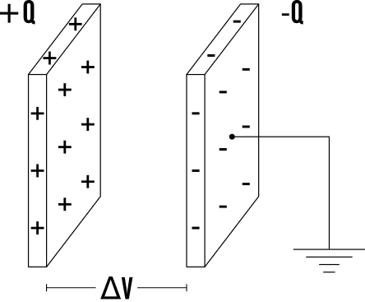

$$E_{∞}= \frac{Q}{ε_{0} A} ∀ internal points$$

$$V_{∞} = E_{∞} d= \frac{Q}{ε_{0} A} d_{min}$$

$$C_{∞} = \frac{Q}{V_{∞} }= \frac{ε_{0} A}{d_{min} }$$

**Model 2: Finite round plate capacitor**

In this model we consider the finite geometry of our capacitor and proceed to calculate the electric potential along the axis of a uniformly charged disk.

The electric field generated by charge dQ at point P is given by:

$$dE= \frac{dQ}{4πε_{0}d^{2}}=\frac{σ dr dl}{4πε_{0}d^{2}}$$

Each infinitesimal stretch of circular corona generates an electric field identical in modulus to that generated by the diametrically opposite stretch. As a result of symmetry, the two vertical components cancel each other while the two horizontal components are summed for each pair of opposite points.

$${dE}_{x}=\frac{σ dr dl}{4πε_{0}d^{2}} cos⁡(θ)$$

We find the electric field generated along the axis by integrating for a distribution of concentric rings:

$${dE}_{r}=\int_{L}{{dE}_{x}= }\frac{σ dr \cos\left(θ\right) }{4πε_{0}d^{2}}\int_{L}{dl}=\frac{σ dr \cos\left(θ\right) }{4πε_{0}d^{2}} 2πr=\frac{σ r dr }{2ε_{0}d^{2}}\cos\left(θ\right)$$

From the definition of cosine, it follows that:

$$\cos\left(θ\right)=\frac{x}{d}= \frac{x}{\sqrt{x^{2}+ r^{2}}} since d= \sqrt{x^{2}+ r^{2}}$$

Now it is possible to write the formula of the electric field generated by the corona in P in the following way:

$${dE}_{r}=\frac{σ r dr }{2ε_{0}d^{2}}\frac{x}{d}=\frac{σ r dr }{2ε_{0}}\frac{x}{{{(x}^{2}+ r^{2})}^{3/2}}$$

Integrating from 0 to R we get the electric field generated along the axis of a disk. Since there are two disks in a capacitor, we multiply it by two:

$$E_{disk}=2\int_{0}^{R}{{dE}_{r}= }\frac{|σ| }{ε_{0}} \left( 1-\frac{x}{\sqrt{x^{2}+ R^{2}}} \right) (x>0)$$

By integrating again, it is possible to find the potential difference between the two armatures:

$$V_{disk}=-\int_{0}^{d_{min}}{ E_{disk} dx= }\frac{Q}{ε_{0}A} \left( d_{min}+R- \sqrt{{d_{min}}^{2}+ R^{2}} \right)$$

From there, the theoretical capacity of the disk is derived:

$$C_{disk}=\frac{Q}{V_{disk} }=ε_{0}A {\left({ d}_{min}+R - \sqrt{{d_{min}}^{2}+ R^{2}} \right)}^{-1}$$

**Note:**

$d$ refers to the generic distance between two points on different plates, $d_{min}$ refers to the minimum distance, i.e. the segment perpendicular to both plates

**Modello 3: Parasitic capacity**

Noting that the disk voltage does not perfectly match what was obtained from the experimental data. We want to futher imporve the model by considering even the parasitic capacitance of the voltmeter.

We then proceed to calculate the parasitic capacitance that allows our model to be compatible with the data using the following formula. The capacitances add up since they are in *parallel*.

$$C_{parasitic}= C_{total}- C_{disk}=Q ∙ \left(\frac{1}{V_{experimental} }- \frac{1}{V_{disk} }\right)$$

**Results**

Interactive data and graphs are available by clicking on the following links:

[10 volts](https://www.desmos.com/calculator/oiitwmcjik) [15 volt](https://www.desmos.com/calculator/kzzdbjxhi7)s [20 volt](https://www.desmos.com/calculator/agbq9bk9nm)s

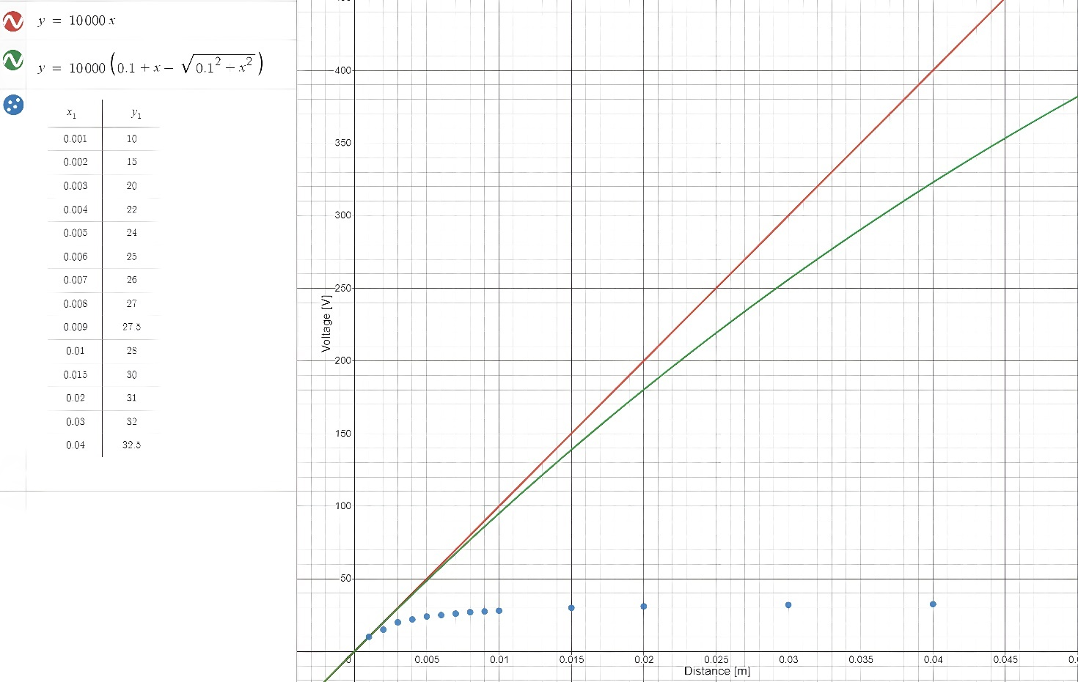

We report only the graph related to the measurements with initial $∆V$ of 10V because all three graphs are similar. As we can see the first two models are unsatisfactory for distances greater than 5mm, indeed towards 10mm we can see that the electric potential tends to saturate (reach a constant value).

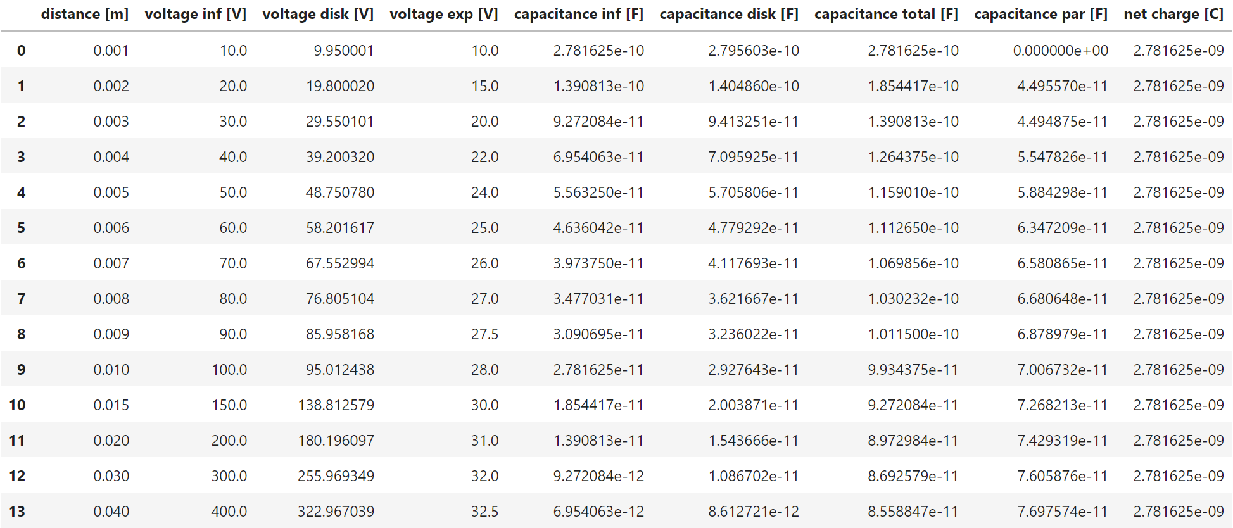

We believe that every researcher should provide maximum transparency on how they analyze data; therefore, we report the following code in Pythond used to perfom our analysis.

As we were advised by the professors, if in the calculations a negative parasitic capacitance was encountered (in our case only at 1mm) it will be considered null. A negative capacitance has no physical meaning.

By averaging the measurements of the parasisitc capacitance, we conclude that it has a mean value of:



$$C_{parasitic}= 5.994141716657975 ∙{10}^{-11} F$$

$$σ \left(C_{parasitic}\right)= 1.9376964418567223∙{10}^{-11}$$

More information about how the code was written is available by clicking [here](https://github.com/Fylls/electromagnetism-experiment/blob/main/analysis/analysis1.ipynb).

**Statisical Analysis**

**Linear Regression**

We report only the analysis for measurements with initial $∆V$ of 10 V since all three cases are similar. However, the complete analysis of the other cases can be found at the following [link](https://github.com/Fylls/electromagnetism-experiment/tree/main/statistics).

The theoretical models initially proposed should approximate the experimental voltage by excess. We study the linear relationship that most closely approximates these models while attempting to optimize the significance of the predictors.

Linear regression using all data first. Refined model later using only the first eight.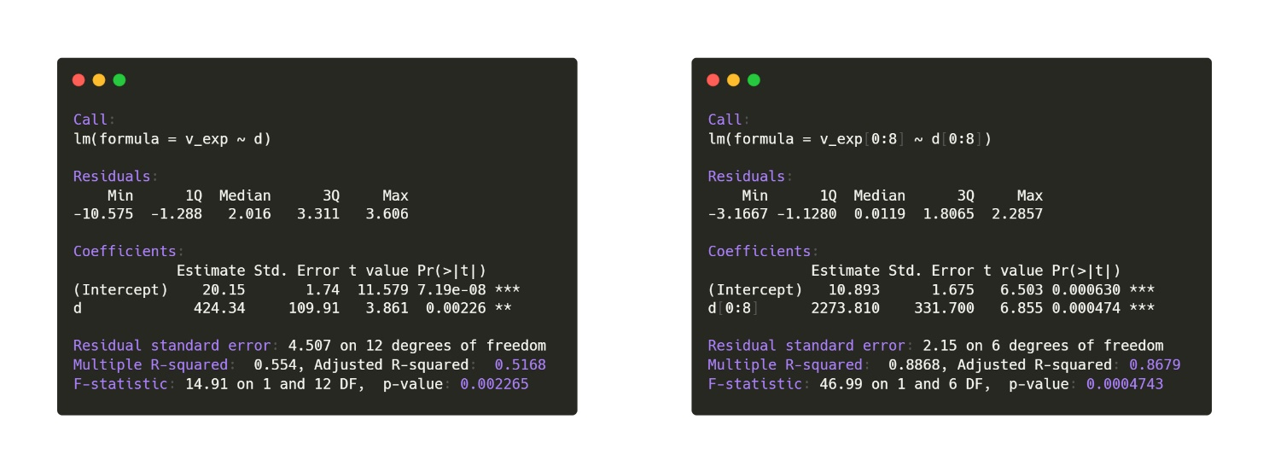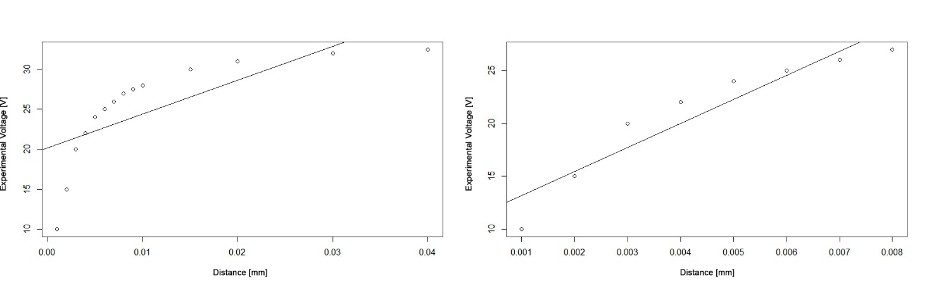

*Density and QQplot for the residuals. SW test p-value: 0.5627 - gaussianity not rejected. From the third plot we note that the residuals are homoskedastic and have a parabolic bias.*

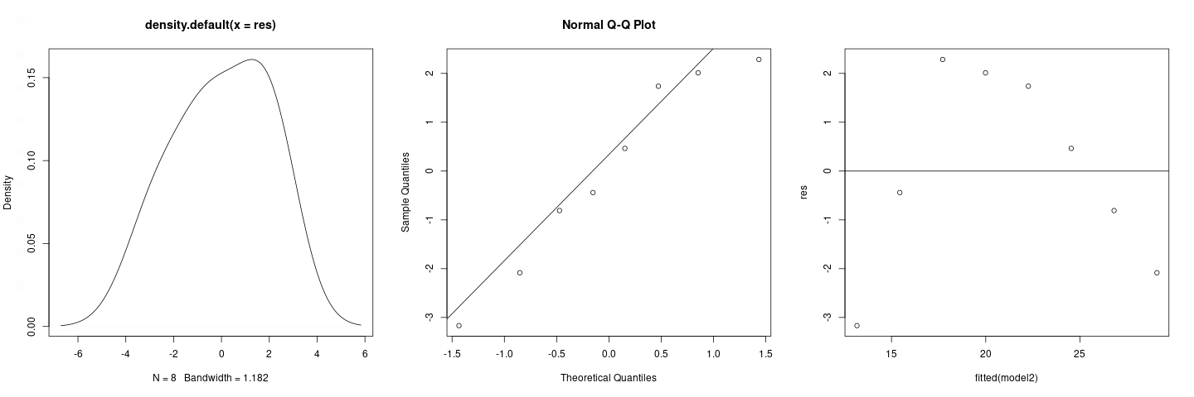

**Normality Analysis**

Studying the QQ-plots we notice that the measurements obtained follow a normal trend; a following Shapiro-Wilk test with a p-value of 0.159 > > 0.05 leads to accept the Gaussianity of the samples. It is important to remember that the Shapiro-Wilk test places the Gaussianity in the null hypothesis H0; this means that it is not possible to strongly assert the Gaussianity of the samples. However, we also do not have strong evidence to reject this hypothesis either. Thus, we have a conclusion that statisticians call "weak". There are no tests that strongly assert the Gaussianity of a random sample.

*Density and QQplot of all experimental data*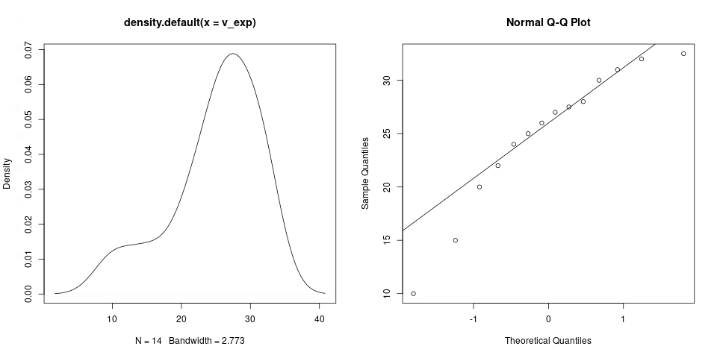

*Density and QQplot for the first eight experimental data (used in the regression) SW test p-value: 0.2287 - gaussianity not rejected*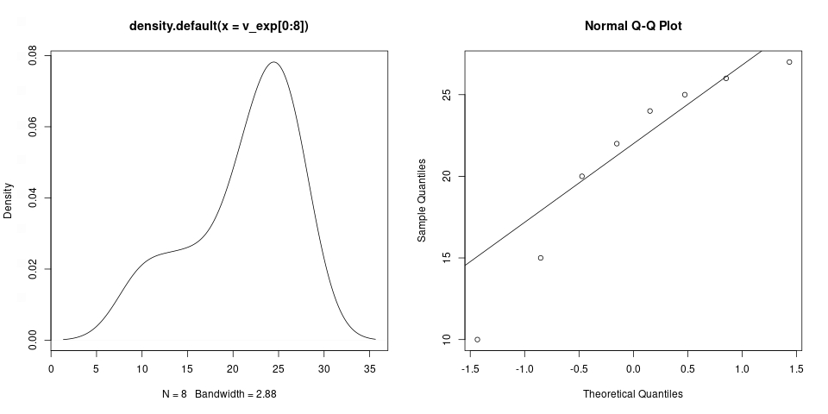

Again, we feel it is our dury to leave the R [code](https://github.com/Fylls/electromagnetism-experiment/tree/main/statistics) used for our analysis.

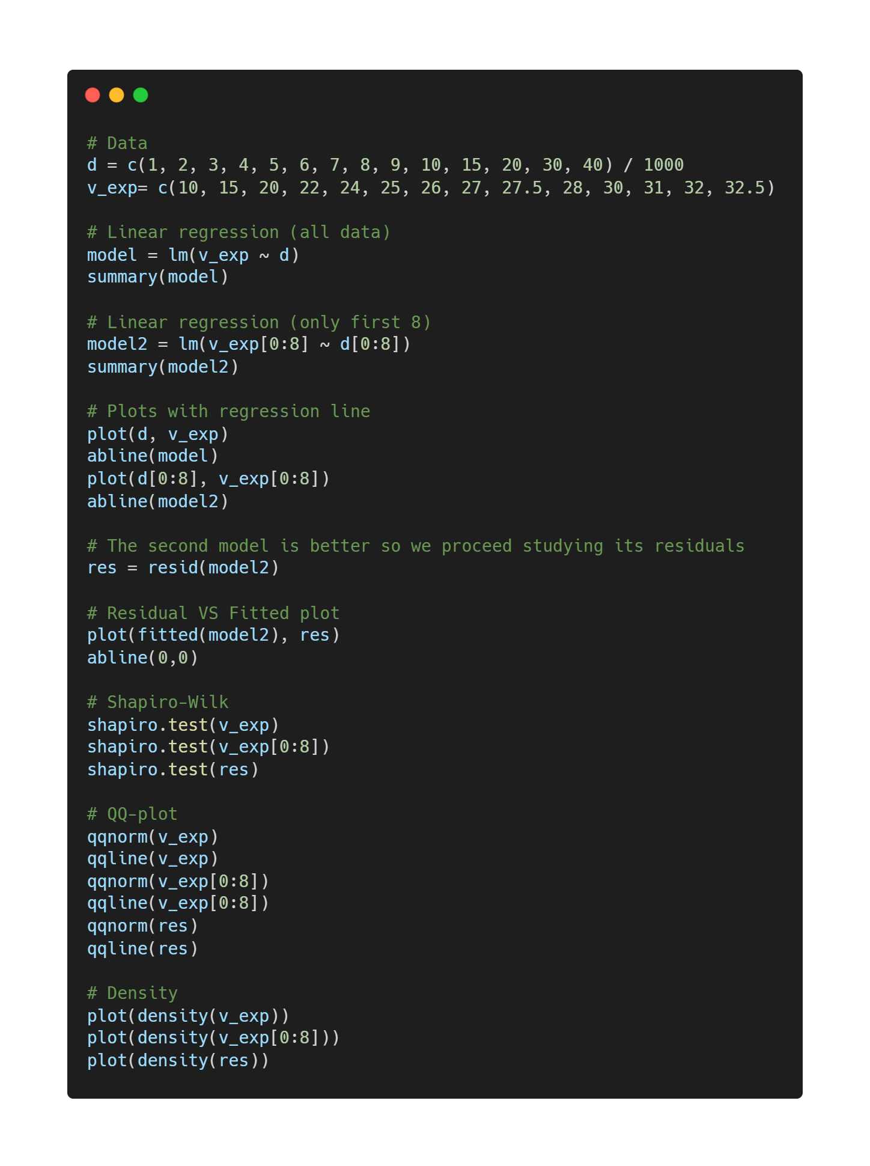

**Experiment 2**

Experimental verification of Laplace's law

**Abstract**

The objective of these experiments is to verify Laplace's law by studying the mutual dependence between the variables involved (current $I$, length of the circuit $L$ and angle $ϑ$ between current $I$ and magnetic field $B$). The theoretical models are compatible with the experimental data, this allows us to study the intensity of the field generated by the magnets with great accuracy.

**Theoretical Background**

**Loretz force:**

It is the combination of electric and magnetic force on a point charge due to electromagnetic fields. A particle of charge $q$ moving with a velocity $v$ in EM fields experiences a force of:

$${\vec{F}}_{Lorenz} = q \vec{E }+q \vec{v}×\vec{B}$$

**Laplace force:**

When a wire carrying an electric current is placed in a magnetic field, each of the moving charges, which comprise the current, experiences the Lorentz force and together they can create a macroscopic force on the wire (sometimes called the *Laplace force*). By combining the Lorentz force law above with the definition of electric current, the following equation results, in the case of a straight, stationary wire:

$${\vec{F}}_{laplace}= I \vec{L} ×\vec{B} \left|F\right|= I L B sin\left(ϑ\right)$$

The direction of the force follows directly from the fact that force F, magnetic field and current density form a right-handed triad (the right-handed rule can be applied)

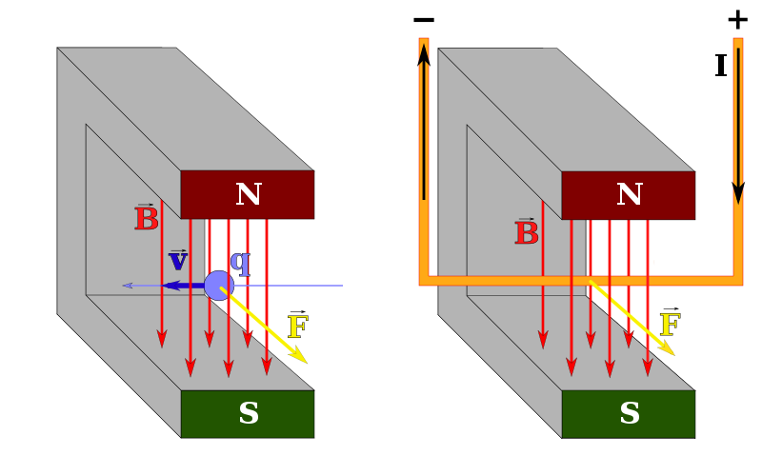

**Experimental Apparatus**

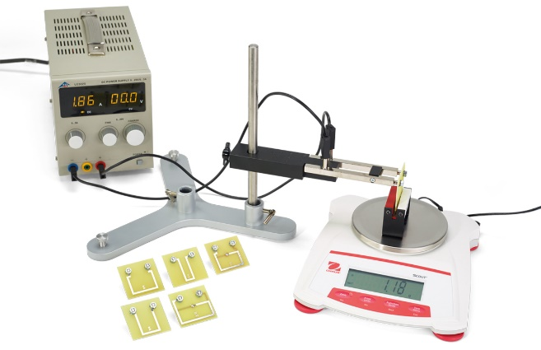

**Set of circuits:** important for the second part of the experiment. Circuits range from 10 to 80 mm in length.

**Horseshoe magnet:** convenient because it generates a uniform magnetic field within its cavity.

**Precision Scake:** digital instrument. Sensitivity in 10-5 Kg (centigram). Tare functionality included.

**DC power supply:** Used to pass direct current within the circuit. Adjustable.

**Rectangular coil**: Mounted on a support that allows a rotation up to 180°. 11 windings.

**Procedure**

**1) Variable current:**

At this stage of the experiment the length of the circuit is fixed at 4 cm while the current is varied from 1 to 4 amperes (A). The circuit is placed inside the magnet cavity perpendicular to the work surface using the conductive support. It is important to keep the circuit parallel to the magnet walls to prevent the angle from affecting the measurements. The field is considered uniform within the cavity, so it is not necessary to place the circuit perfectly in the center, however we still recommend it

The magnet is located on the precision scale because with this configuration we can indirectly measure the vertical force acting on it in correspondence of the different current values set on the generator. This is possible because of Newton’s third law of motion (For every action, there is an equal and opposite reaction)

Magnet and current are oriented in such a way as to produce a downward force, since our precion scale was more accurate for positive changes in mass and not vice versa.

The total force acting along the vertical direction is the vector sum of the weight force and the (reaction of the) Laplace force; fortunately, the balance can measure relative variations with respect to an indicated mass, this allows to know with simplicity the variation of apparent mass due to the action of the force.

The Laplace force is obtained by multiplying the variation of mass in kilograms by the acceleration of gravity.

$$F_{Laplace}= ∆m∙g=I L B$$

$$we assume sin\left(ϑ\right)=1 → ϑ = π/2$$

**2) Variable Length:**

In this pahse of the experiment the current is fixed at 3 amperes (A) while the legnth of the circuit was varies. under these different conditions we repeat the same procedure as previously explained.

The length L varies since we mount different circuits included in the kit. Lengths vary from 10 to 80 mm.

For safety reasons, it is imperative to turn off the power generator before changing the circuit. In any case the current of 3 A is high enough to have visible results but not enough to create dangerous situations.

$$F_{Laplace}= ∆m∙g=I L B ( ϑ =π/2 )$$

**3) Variable Angle:**

In the last pahse we use a special tool, we can vary the angle between current density and magnetic field precisely without affecting the structure of the system (which is like previous cases). The circuit length and current intensity are both constant at 1 cm and 3 A, respectively. The loop has N=11 windings.

$$F_{Laplace}= ∆m∙g=N I L B sin\left(ϑ\right)$$

**Results**

Interactive data and graphs are available by clicking on the following links:

[current](https://www.desmos.com/calculator/h4bduk6eou) [length](https://www.desmos.com/calculator/zjzzpchrwf) [angle](https://www.desmos.com/calculator/kxejprp3qt)

**1) Variable current:**

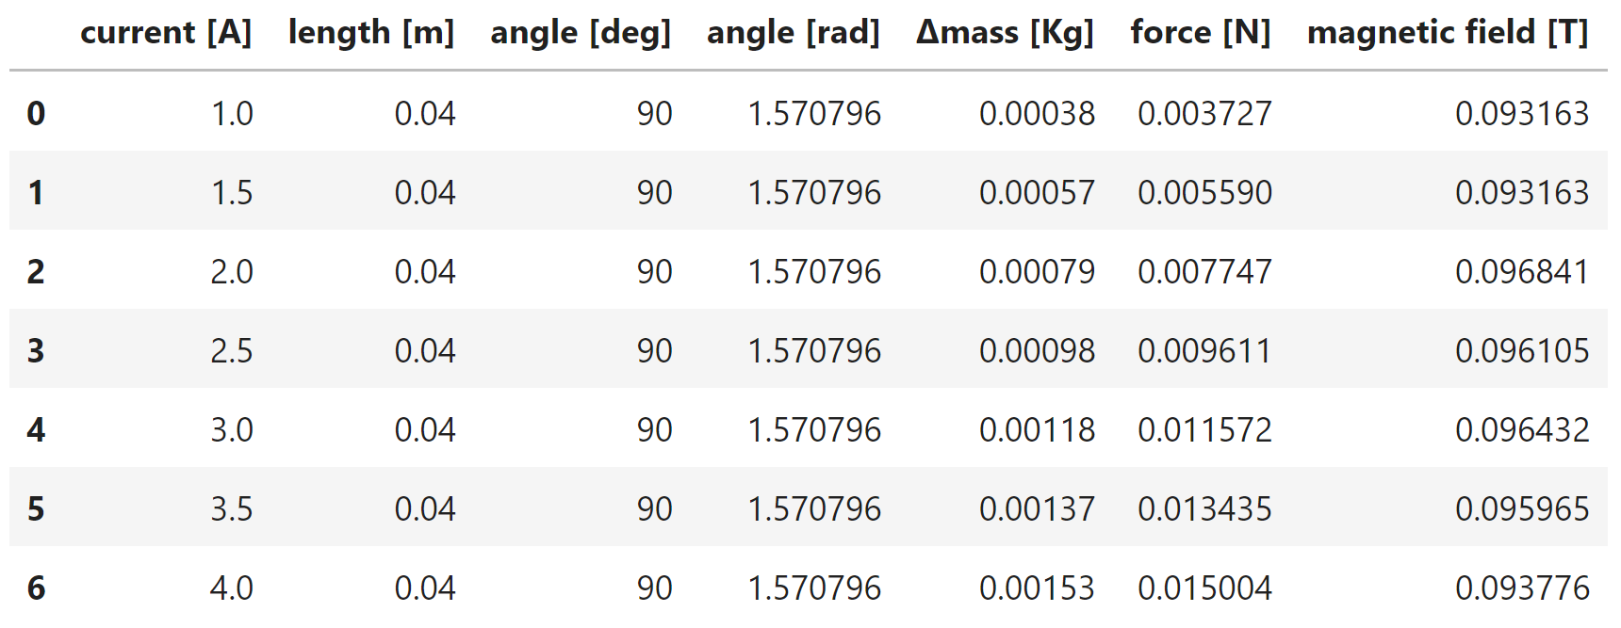

$$B_{1}=\frac{F_{Laplace}}{I L }= 0.09506363038690477 T$$

$$σ \left(B_{1}\right)= 0.0015028110582847372$$

**2) Variable Length:**

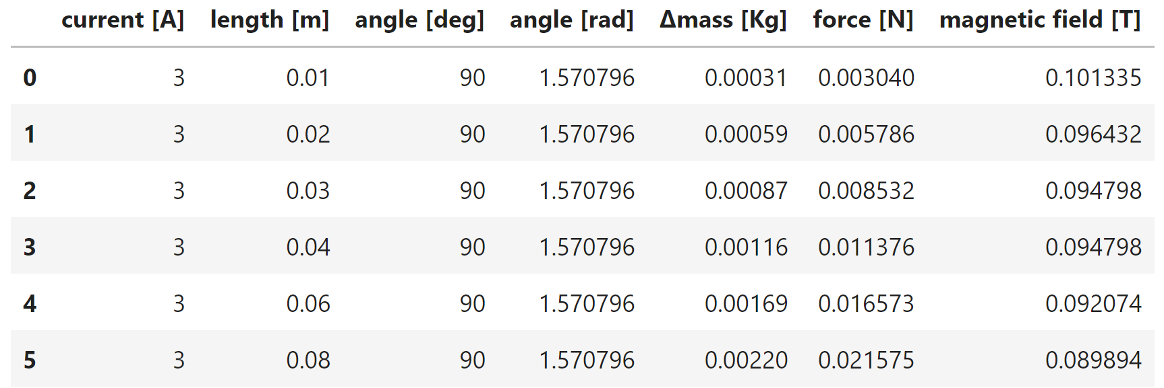

$$B_{1}=\frac{F_{Laplace}}{I L }= 0.09488841898148148 T$$

$$σ \left(B_{1}\right)= 0.0035783486084375207$$

**3) Variable Angle:**

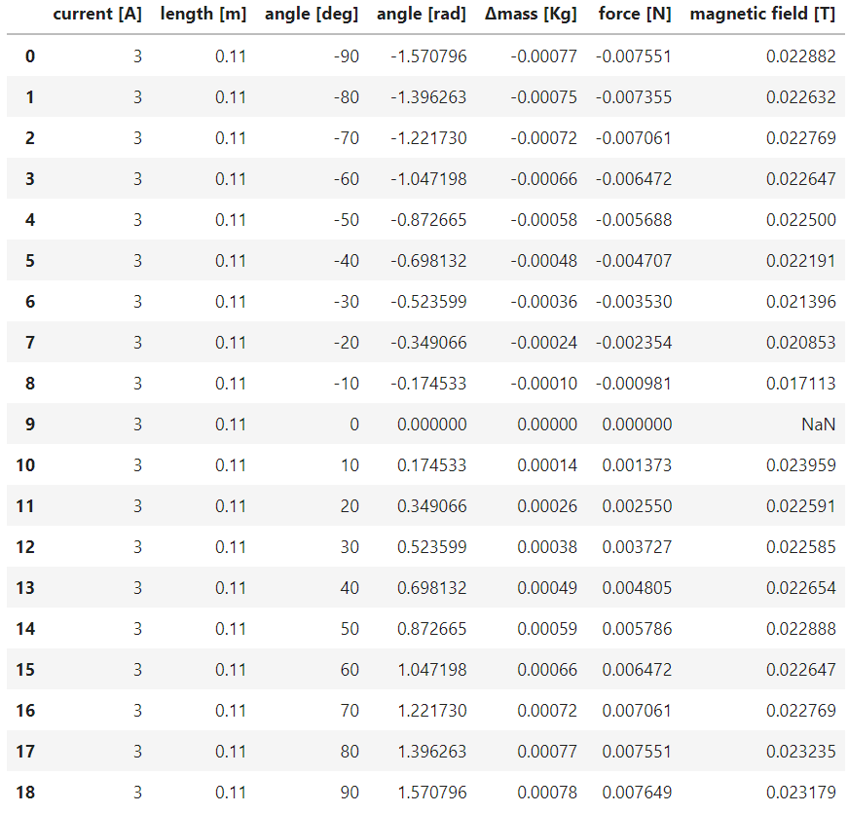

$$B_{2}=\frac{F_{Laplace}}{N I L sin\left(ϑ\right)}= 0.02230510145458343 T$$

$$σ \left(B_{2}\right)= 0.0014147961692990447$$

The magnet used in the first two experiments (B1) is different from the one used in the third (B2). Considered with their errors, the two values of B1 are compatible and converge towards *0.095 T*.

The magnetic field in the third table in line 9 (highlighed in yellow) is “NaN” or in other words undefined since we are trying to divideby zero. This is because when the angle approaches zero, so does its sine.

For the correct calculation of the magnetic field, it is necessary to convert the angles in radians.

The average value of the magnetic field can also be found as the first order coefficients in a linear regression that we will discuss later. (The intercept has very high p-value, so we can exclude it from the model)

As in the previous cases here is the code for our analysis. More information [here](https://github.com/Fylls/electromagnetism-experiment/blob/main/analysis/analysis2.ipynb).

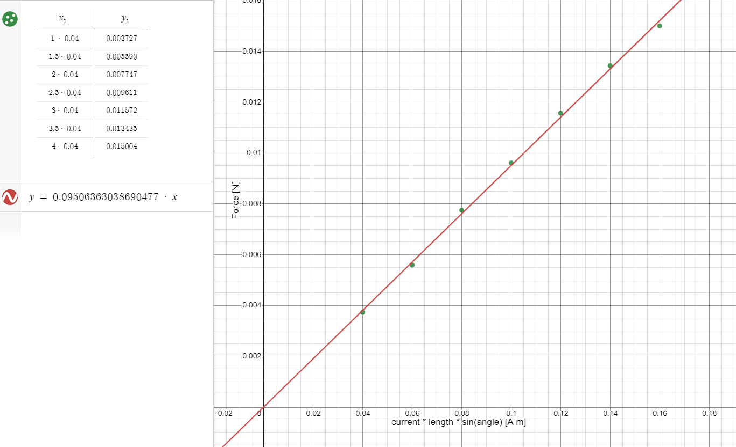

**Statistica Analysis**

**1) Variable Current:**

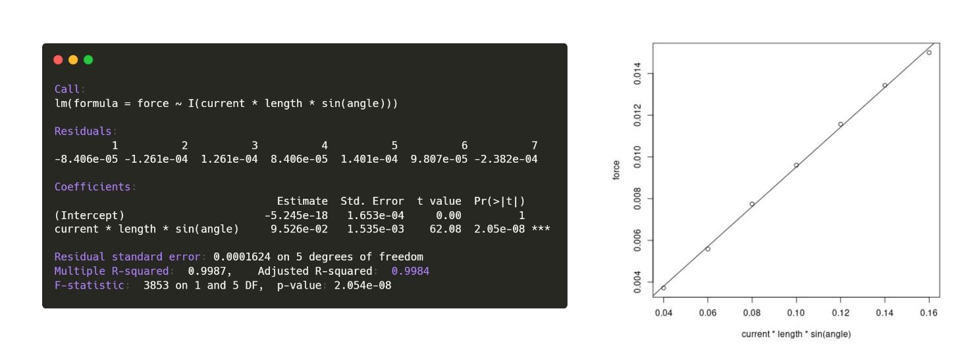

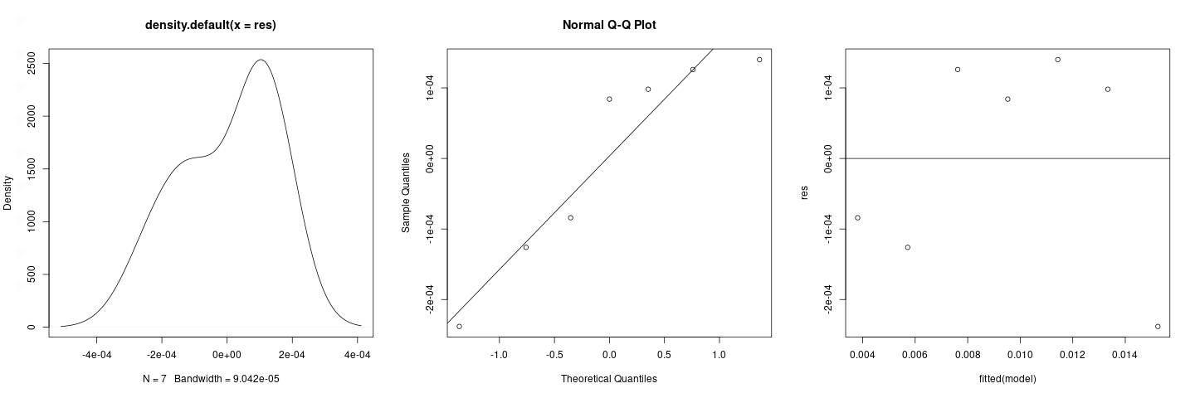

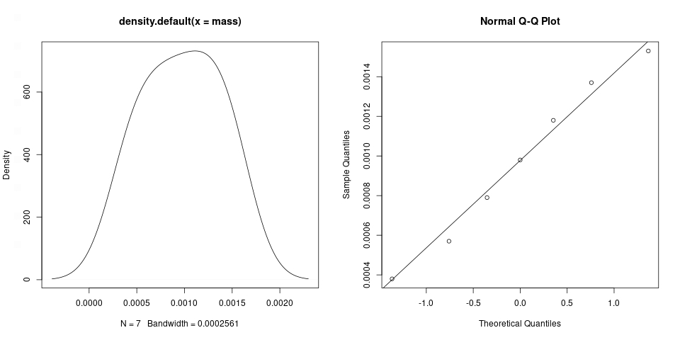

Gaussianity is not rejected for both samples and residuals; further confirmation of this comes from the Shapiro-Wilk test: *0.9099 >> 0.05* for mass, *0.1685 > 0.05* for residuals. From the “res VS fitted” plot, we can see some hint of homoschedasticity: the residuals have finite variance and a cloud-like arrangement. As the low p-value of the F-test tells us, the overall model is highly significant with satisfactory R2 e R2adj. Since the p-value of the intercept is maximum (1) this makes us sure that not to consider it in the model.

**2) Variable Length:**

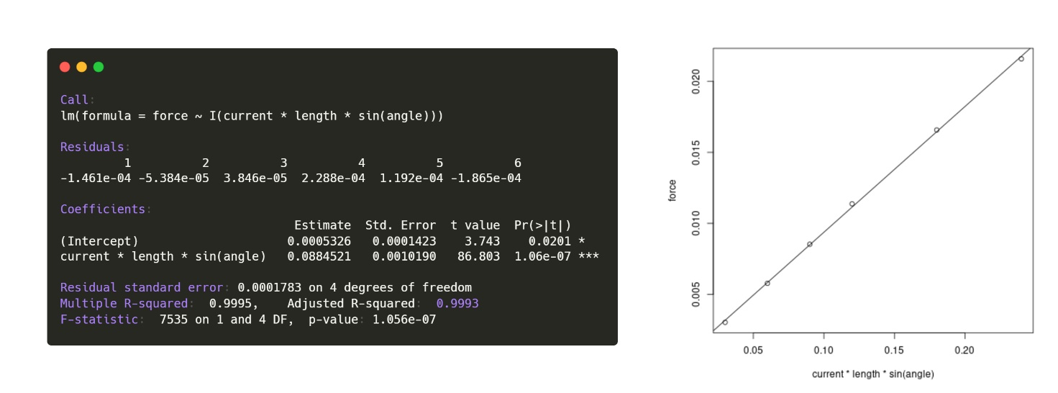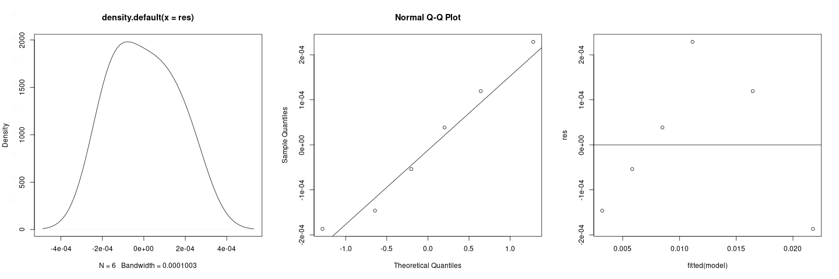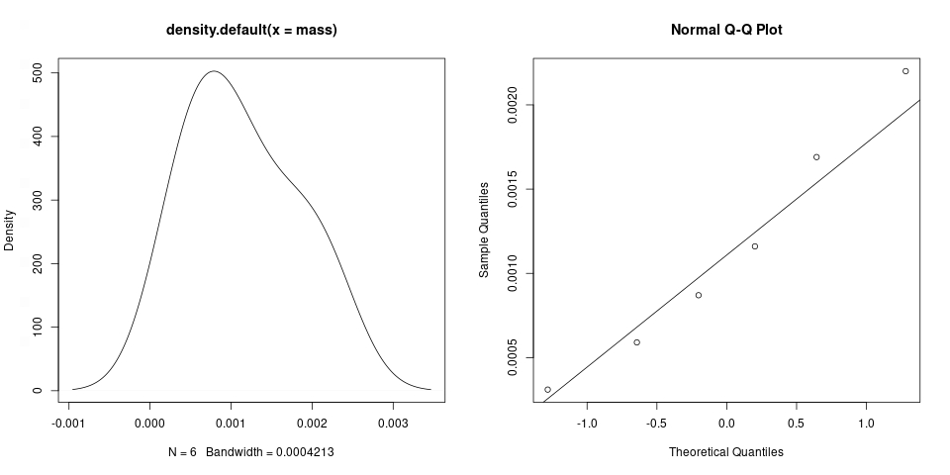

Gaussianity not rejected for both samples and residuals; further confirmation of this comes from the Shapiro-Wilk test: *0.8505 >> 0.05* for mass, *0.8359 >> 0.05* for residuals. From the “*res VS fitted*” plot, we can see there is a certain homoschedasticity with non-linear bias (maybe parabolic). In any case the residuals are perfectly kept within the ±2 margins of the normalized plot. It is not possible to conclude more due to the lack of data. As the low p-value of the F-test tells us, the overall model is highly significant with satisfactory R2 e R2adj. Intercept less significant than the other predictor (0.0201 >> 10-7) this allows not to consider it in the model.

**3) Variable Angle:**

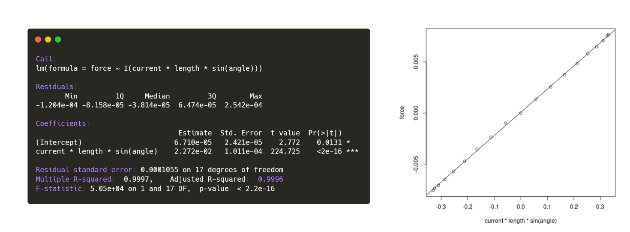

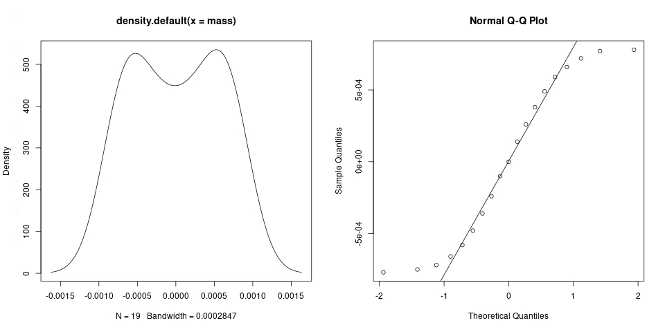

Non-rejectionable Gaussianity for samples only. From the Shapiro-Wilk test we get *0.05728 > 0.05* for mass, *0.02078 < 0.05* for residuals. There is no certainty about the homo or heteroschedasticity of the residuals, all we can say from the plot "res vs fitted" is that the residuals do not have a linear trend, they have finite variance but the pattern they describe does not seem to have a random trend. As the low p-value of the F-test tells us, the overall model is highly significant with satisfactory R2 e R2adj. Intercept less significant than the other predictor (0.0201 >> 10-16) this allows not to consider it in the model. R2 e R2adj are satisfactory.

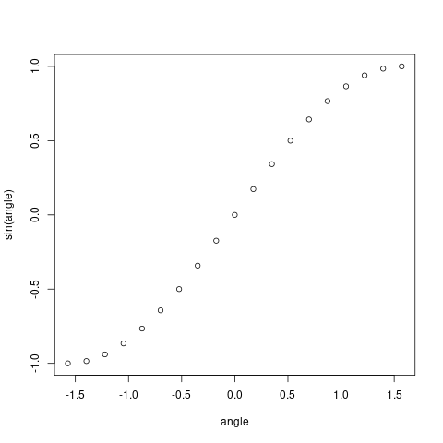

As per practice we leave the code used for the statistical analysis. More info [here](https://github.com/Fylls/electromagnetism-experiment/tree/main/statistics).

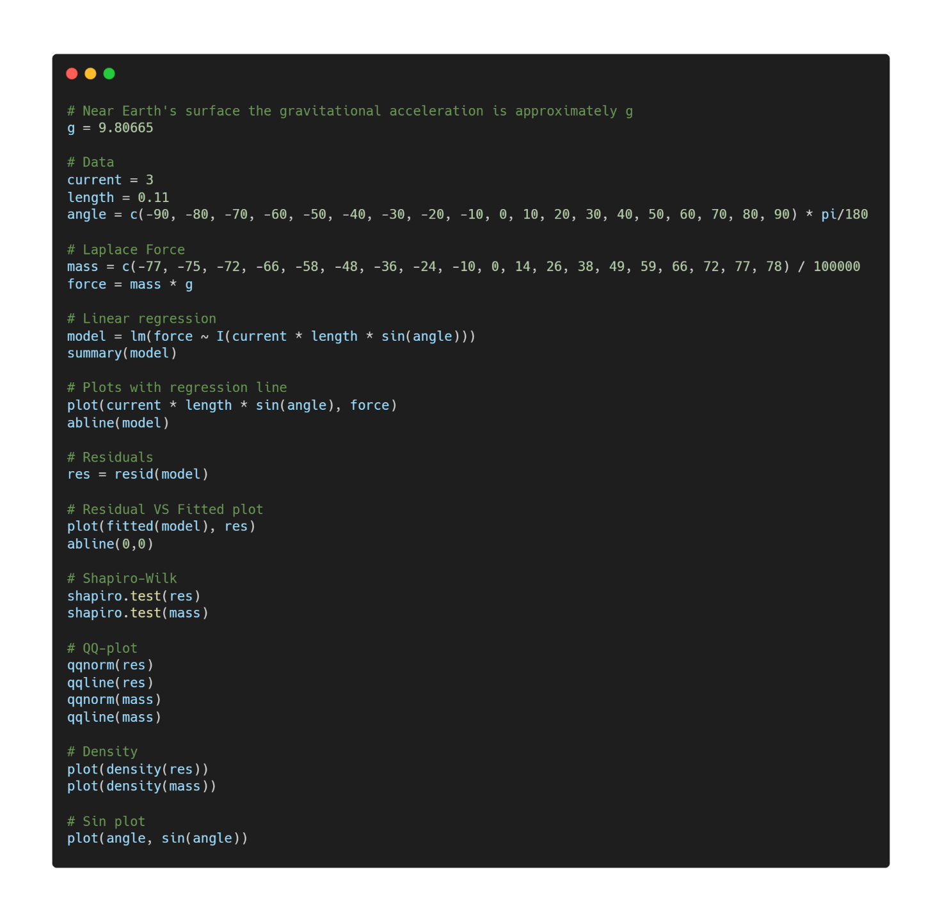

**Conclusions**

In general, this experience turned out to be very instructive, not only from a notionistic point of view but especially because it allowed us to appreciate the differences between theoretical models and experimental data, pushing us to find reasons for these inconsistencies. Physics is fascinating even when it doesn't work!

**Acknowledgements**

**Software:**

**R:** programming language

**Python:** programming language

**Numpy:** python library

**Pandas:** python library

**Seaborn:** python library

**Scipy:** python library

**Jupyter Notebook:** IDE for python

**Adobe** **Photoshop:** photo editing software

**Web Services:**

**Carbon.now:** easy sharing of source code via images

**Rdrr.io:** online IDE for R (R studio alternative)

**Imgonline.com.ua:** online tool for quick image editing

**Github.com:** opensource repositories. All the material of this research can be found here

**Desmos.com:** online graphic calculator. Useful for sharing interactive graphs

**Images:**

**Pasco Scientific**: esperimental apparatus

**Wikipedia:** illustrations

**YouMath**: illustrations

**Literature:**

**Ioannidis** (2005) "Why Most Published Research Findings Are False"